Automate the below Task using Selenium WebDriver Framework

1. Validate the below steps using Selenium WebDriver using Maven Project
2. TestNG framework should be used.
3. Do create TestNG.XML file and execute the test method using TestNG.XML file
4. Generate HTML Report using Extent Report.
5. You should be able to execute the same from the command prompt.

Step 1: URL : <https://www.makemytrip.com/>

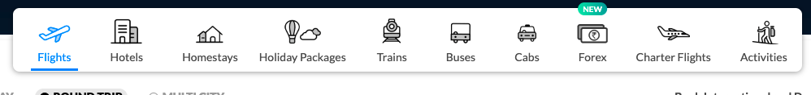

Select Holiday Packages.

Step 2: Select the From City as Bangalore & To City as Singapore & Click on Search.

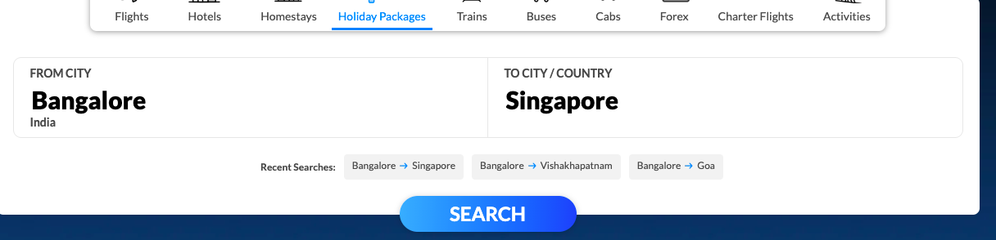

Step

Step 3 : Select the Start Date from the Date Picker & Click on search



Step 4 : Scroll and Select 2N/3D

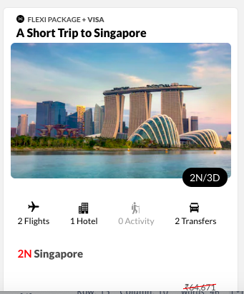

Step 5: Click on change to select a new Hotel

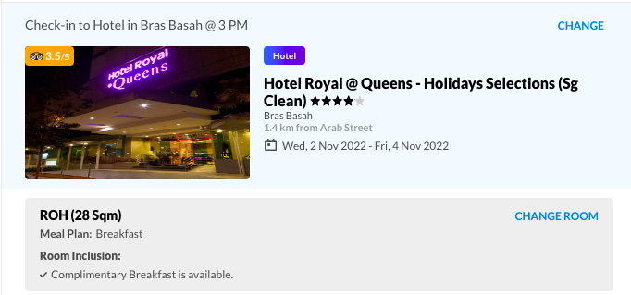

Step 6: Scroll and select the below hotel

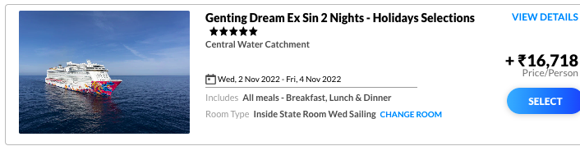

Step 7 click on update packages.

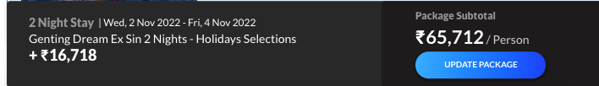

Step 8 : Selected hotel should be reflected in the Itinerary, Apply validation for the same.

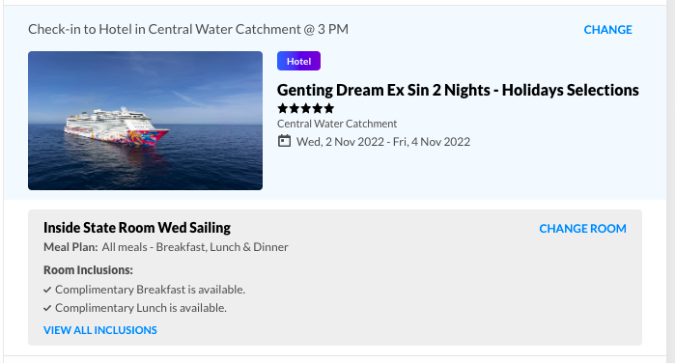

Step 9 scroll and click on Add Activity & Select the below activity in the image.



Step 10 Click on Update packages.

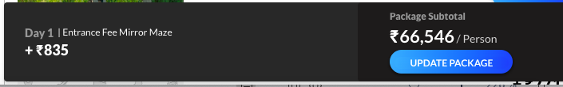

Step 11: validate the select activity updated successfully.

Step 12: Click on each link and validate all the selected hotel and activity is reflected.



Step 13: Close the browser